DEEPAN HARIS N  B.Tech Information Technology | First Year, Semester 1  PHONE: 7305313365  EMAIL: deepanharisnachiappan@gmail.com  GITHUB: https://github.com/deepanharis10613-wq  LOCATION: Karaikudi | 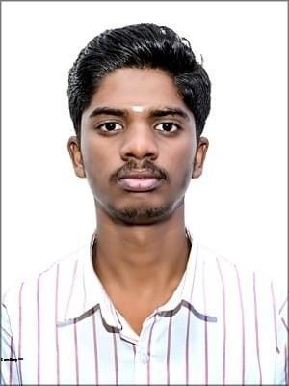

PROFILE SUMMARY
Motivated first-year B.Tech Information Technology student interested in programming, web development, and digital creativity. Currently building foundational skills in C, C++, Python, Java, SQL, and front-end technologies, with interests in video editing, content creation, and story writing. Eager to learn through hands-on projects and teamwork.
EDUCATIONAL DETAILS
QUALIFICATION | INSTITUTION | YEAR | MARKS / STATUS
SSLC | Karaikudi Maharishi Vidhya Mandir Matric Higher Secondary School, Karaikudi | 2023–2024 | 363/500 (72.6%)
HSC | Karaikudi Maharishi Vidhya Mandir Matric Higher Secondary School, Karaikudi | 2025–2026 | 349/600 (58.2%)
B.Tech IT | Mount Zion College of Engineering and Technology | 2026–Present | Pursuing
TECHNICAL SKILLS
CATEGORY | SKILLS | CURRENT LEVEL
Programming | C, C++, Python, Java | Proficient
Web | HTML, CSS | Proficient
Database | SQL | Proficient
Office Tools | MS Word, MS Excel, MS PowerPoint | Skilled
Design | Canva | Skilled
GITHUB PROFILE
https://github.com/deepanharis10613-wq | Add selected projects/repositories here as you create them.
ACHIEVEMENTS & CERTIFICATIONS

HOBBIES & INTERESTS
Coding • Video editing • Content creation • Story writing

